 | Abdi İpekçi Caddesi Kaşıkçıoğlu Apt. No:42 D:2 34365 Nişantaşı İstanbul  www.artxist.com  info@artxist.com  T. +90 212 291 77 84 F. +90 212 343 69 35 | PRESS RELEASE

ART BEAT 2011
x-ist participates in Art Beat, a major new contemporary art fair taking place between 14- 18 September, 2011 at Lutfi Kırdar Convention and Exhibition Center, Istanbul.

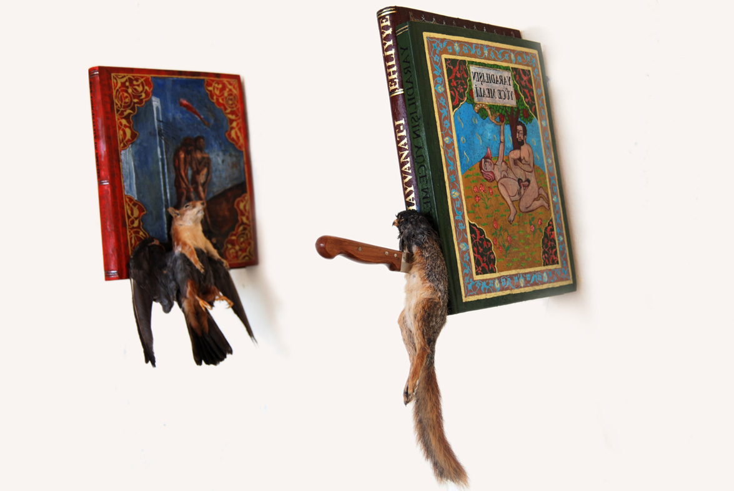

Burhan Kum, Palimsest I & Palimsest II, 20 x29 x 51 cm/7 x 46 x 57 cm, 2011

Art Beat, which coincides with the opening of the 12th Istanbul Biennial, will be an essential gathering point for collectors, artists and art professionals from across Turkey, the Middle East, Europe, Asia, and beyond.

x-ist participates in Art Beat with the works of Ali Elmacı, Ansen, Ali Taptık, Burhan Kum, Nalan Yırtmaç, Nuri Kuzucan and Seda Hepsev. The fair aims to create a platform to present reflections of artists’ deep interior, removing themselves from the rules and influences of the external world, taking art-lovers on a surreal night journey. The artists, well known for their unique styles and visual languages, come together with their different approaches in this collection of works on exhibition at the fair.

x-ist invites all those interested in taking the pulse of Turkish contemporary to see these unique and special works prepared specifically for Art Beat and Biennale visitors.

